Digital Chip Design Program
RTL Design
Alia Alsultan
Aryam Alharbi
Elaf Alkhalaf
Lana Aldhali
Manar Alnuqaydan

30/06/2026
Data _Flow

Task #2.1

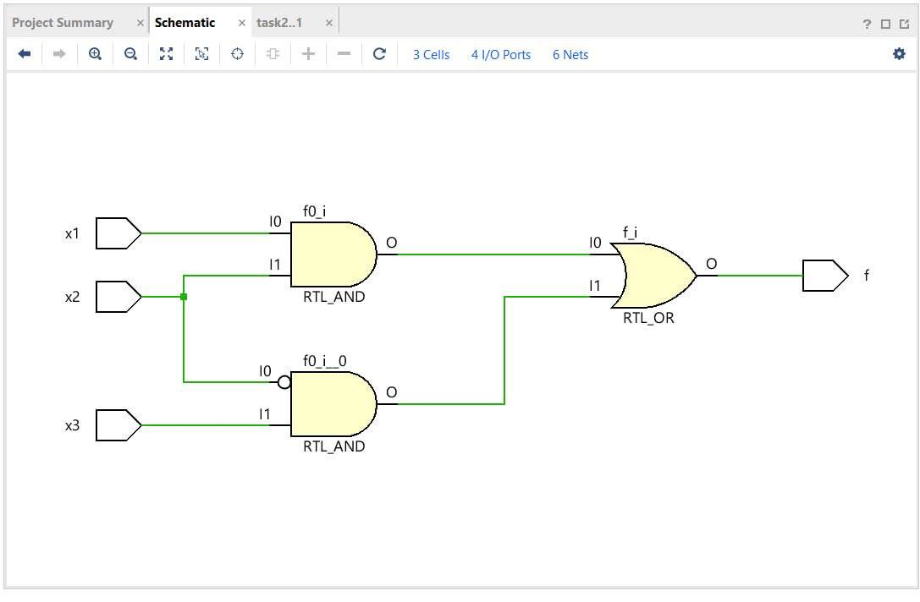

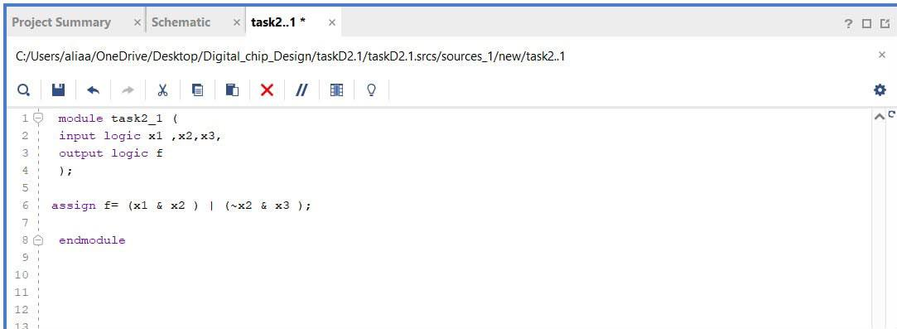

Task #2.2
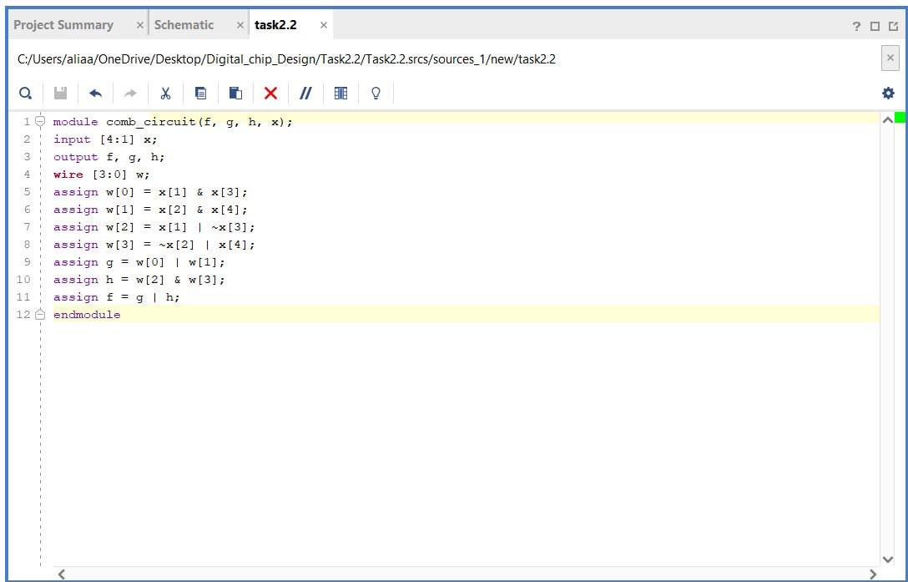

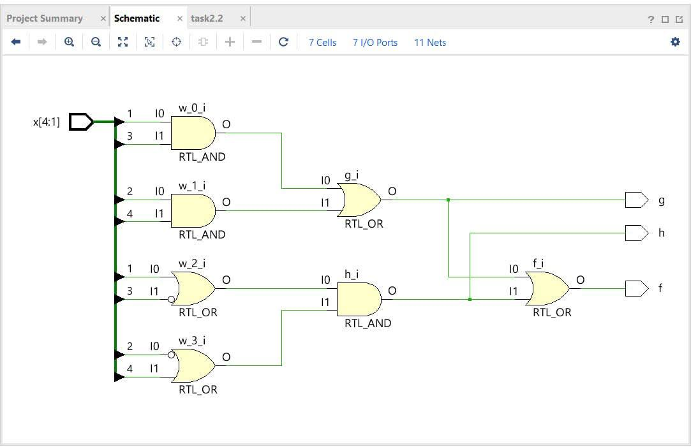

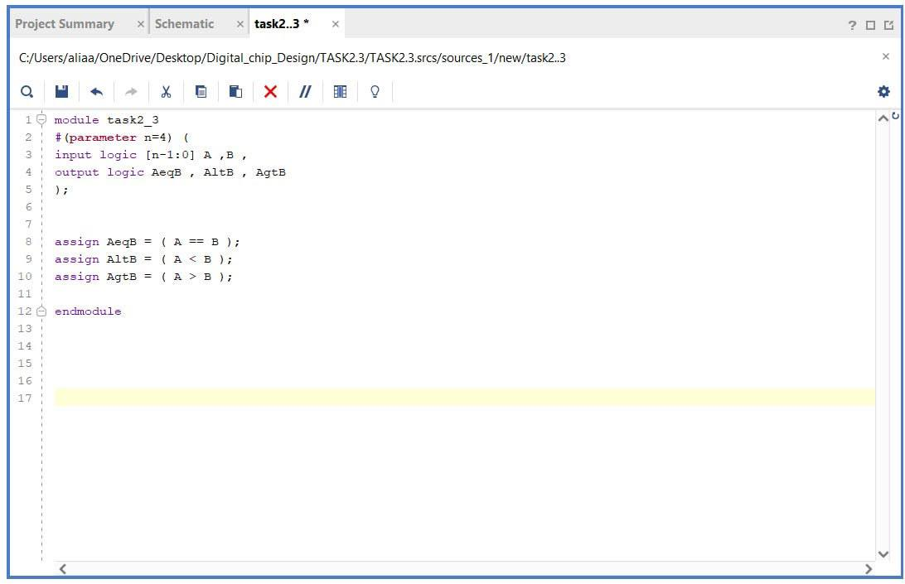
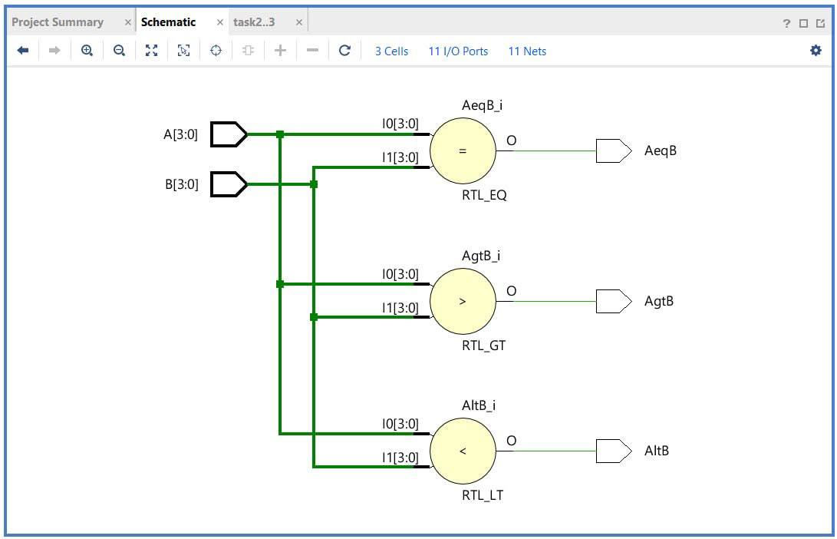
Task #2.3

Work distribution

Section | Alia | Aryam | Elaf | Lana | Manar
Report | ✔ | ✔ | ✔ | ✔ | ✔
Task n.x | ✔ | ✔ | ✔ | ✔ | ✔
Task n.x+1 | ✔ | ✔ | ✔ | ✔ | ✔
Task | ✔ | ✔ | ✔ | ✔ | ✔

